**Lab Manual # 9**

**ME-XXX:Computer Systems and Programming**



## Submitted by:

**Muhammad Hamza (467023)**

**DEPARTMENT OF MECHANICAL ENGINEERING**

**NATIONAL UNIVERSITY OF SCIENCES AND TECHNOLOGY,H12**

# LAB TASK

## LAB TASK 1:

**Make 2D Array in C++ and print left diagonal and right diagonal sum of a 3x3 matrix.**



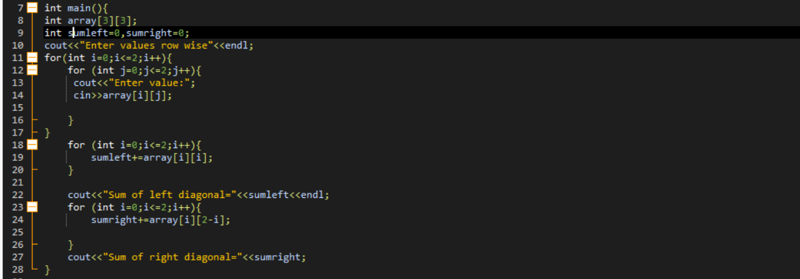

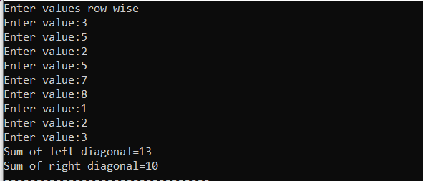

## LAB TASK 2:

**Write a function to add two 2D arrays of size 3x3.**

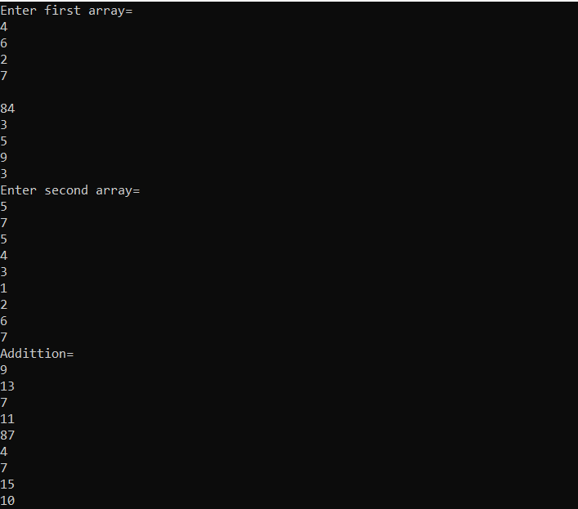

## LAB TASK 3:

**Using 2D arrays in C++, take transpose of a 3x3 matrix. Make a transpose function.**

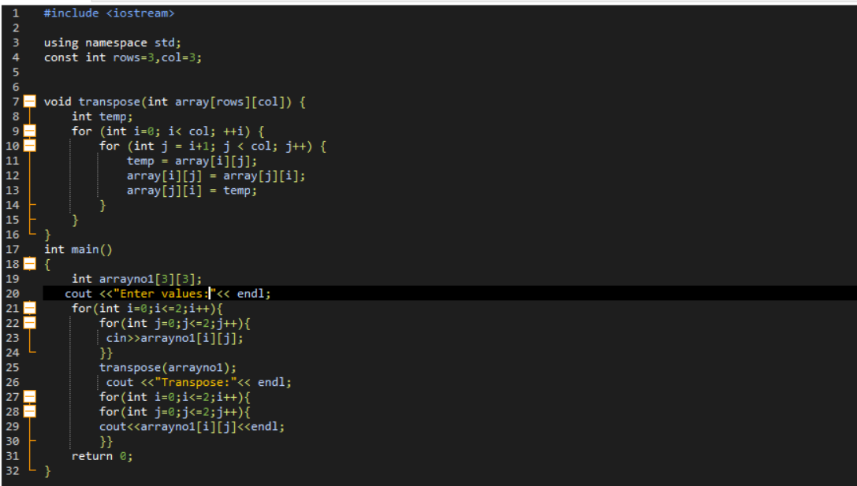

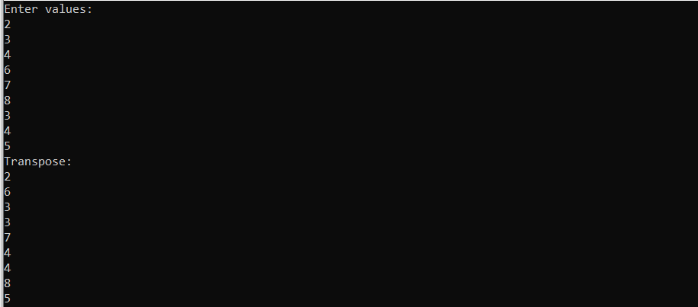

## LAB TASK 4:

**Using 2D arrays in C++, implement 3x3 matrix multiplication. Make a function.**

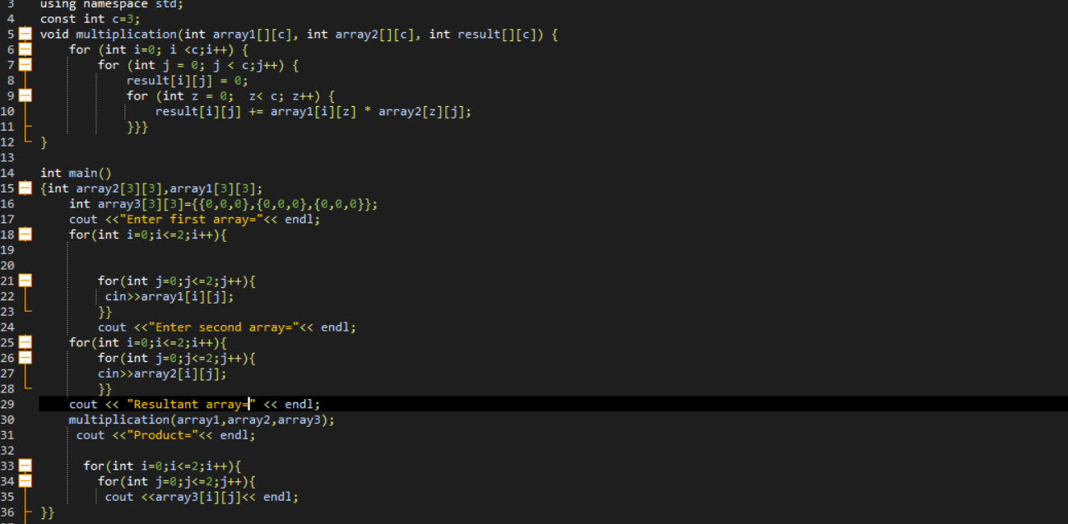

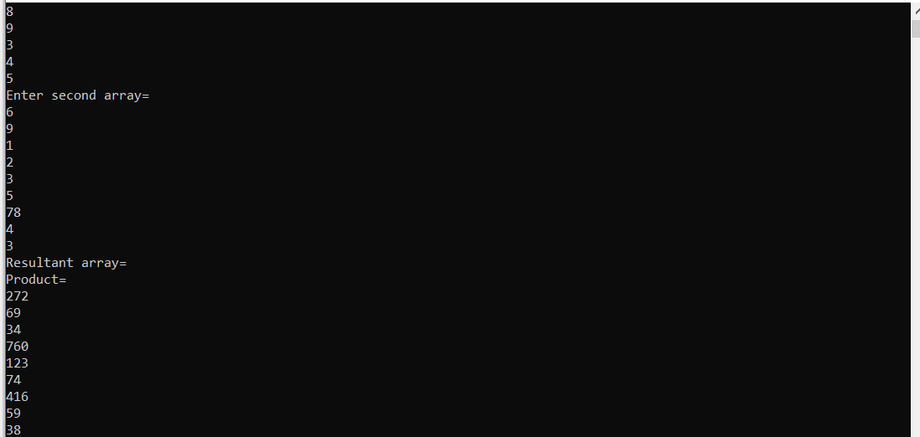

## LAB TASK 5:

**Print the multiplication table of 15 using recursion.**

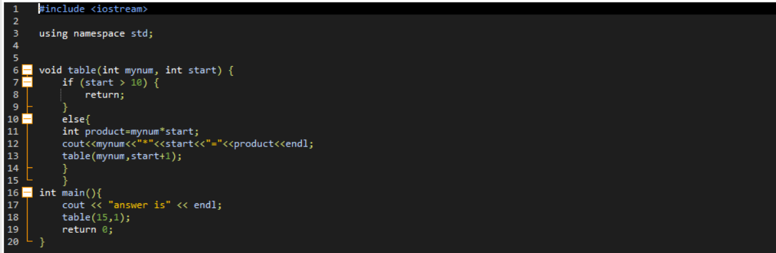

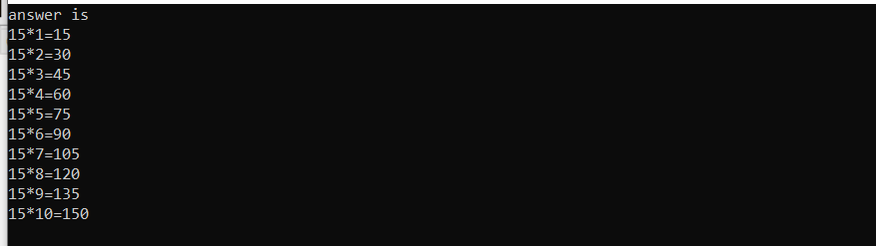

# HOME TASK

**Write a C++ program to take inverse of a 3x3 matrix using its determinant and adjoint.**

